IVAN Comments
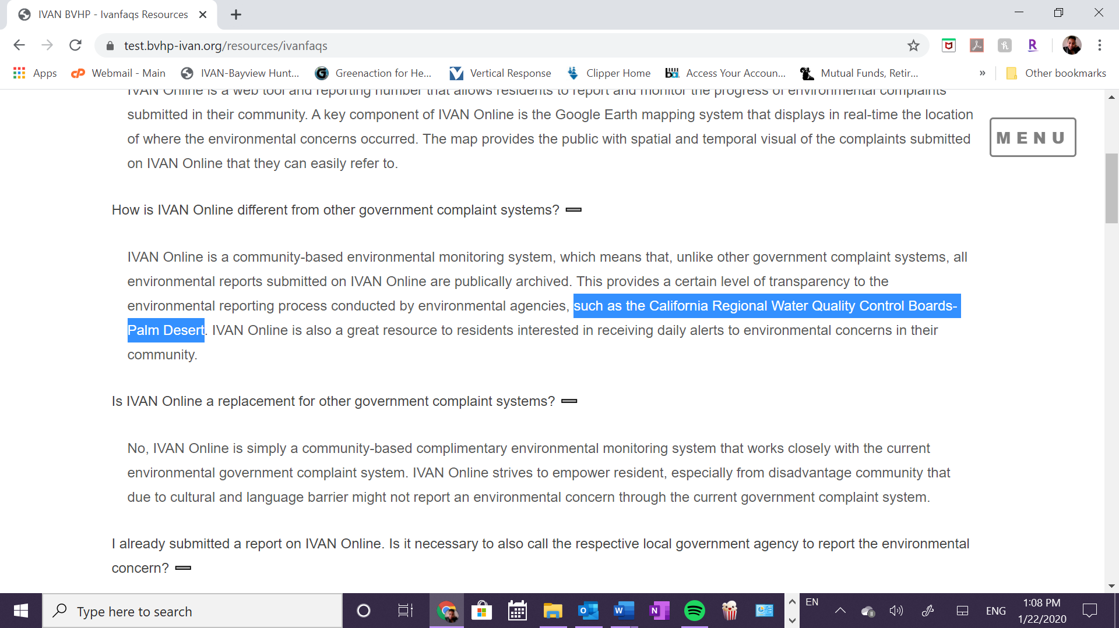
Cambiar California Regional Water Quality Control Boards-Palm Desert a “Bay Area Air Management District”
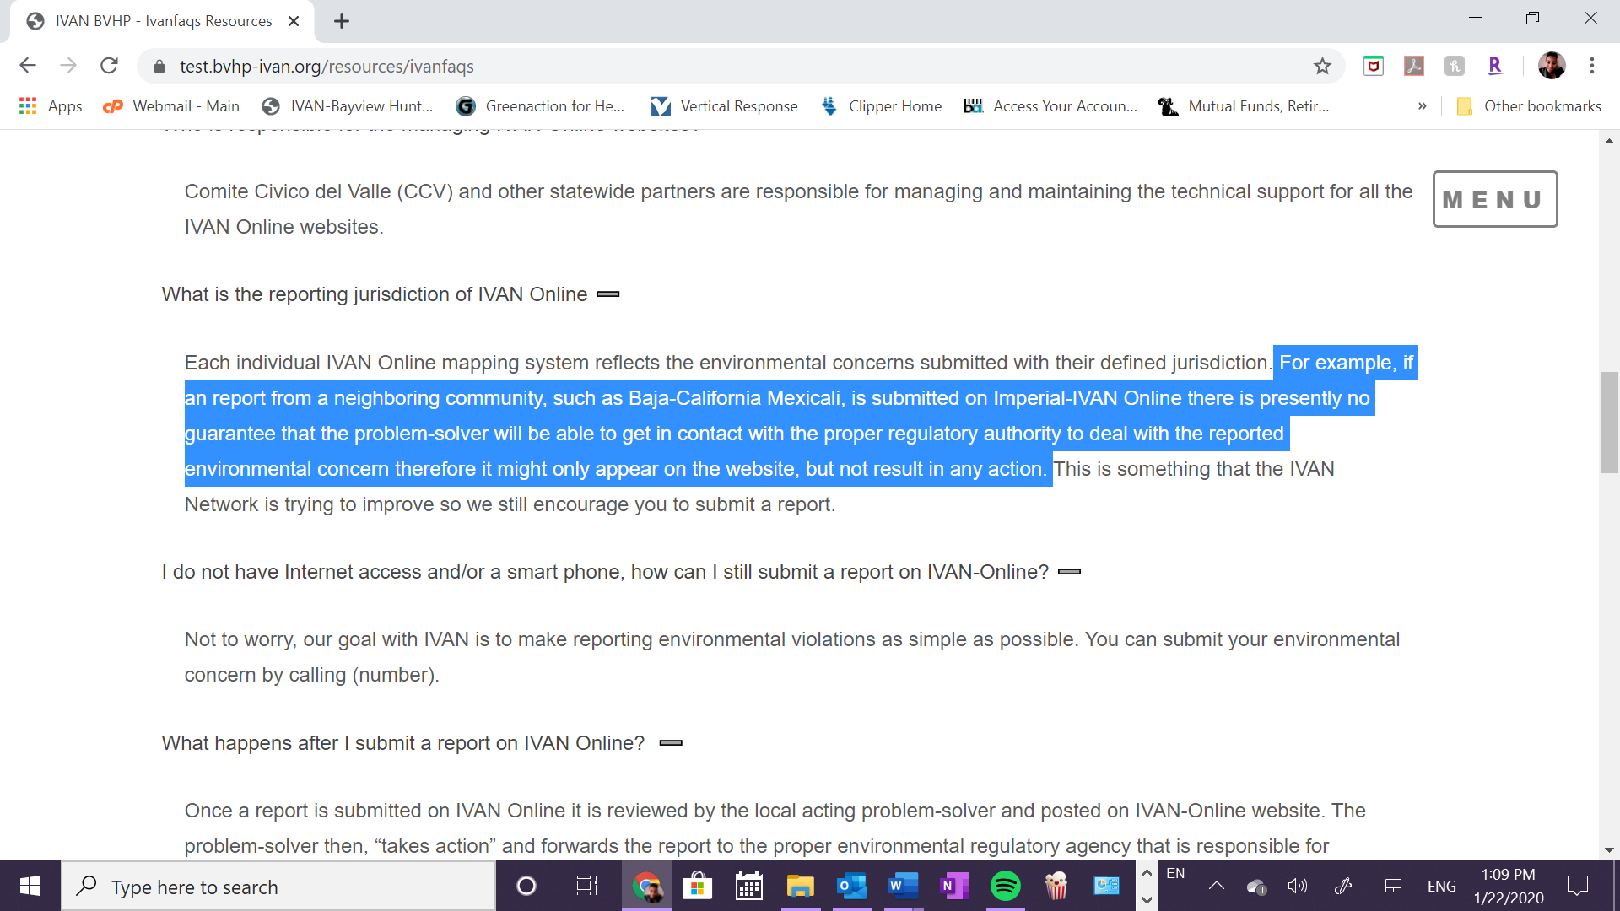
Cambiar con “Dogpatch or Visitacion Valley” donde dice Baja-California Mexicali

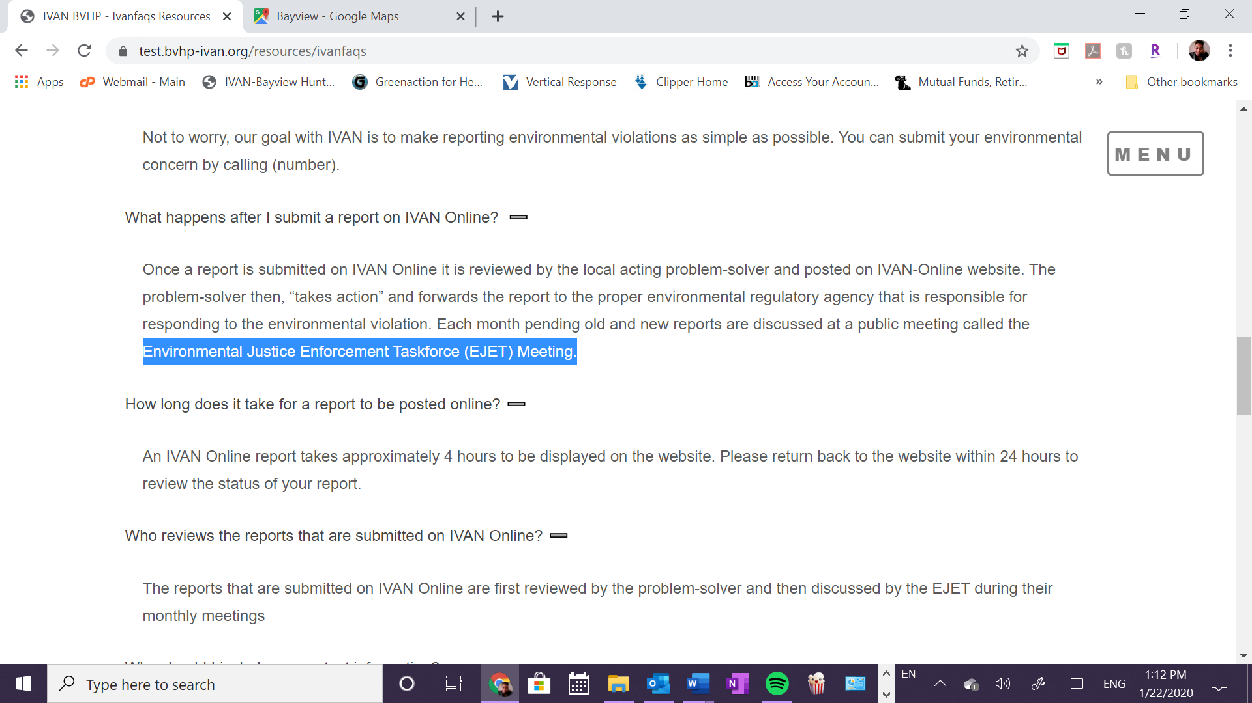
Cambiar a “Environmental Justice Response Task Force Meeting”
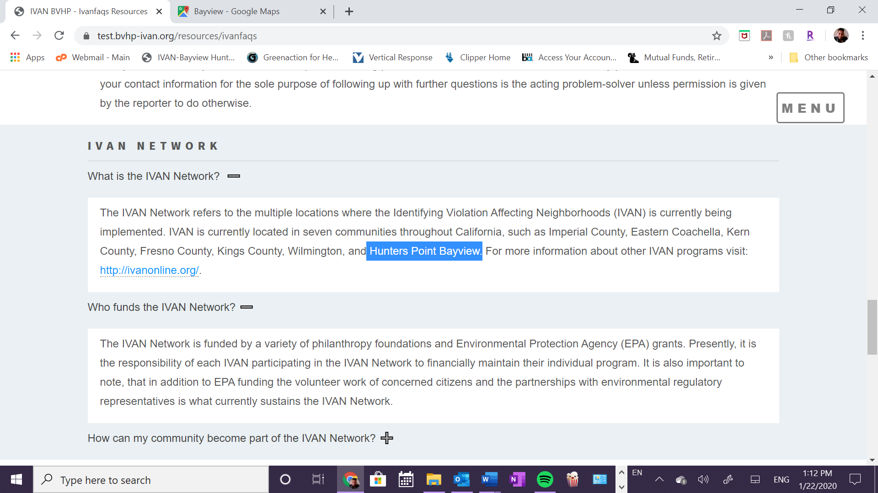
Corregir a “Bayview Hunters Point”
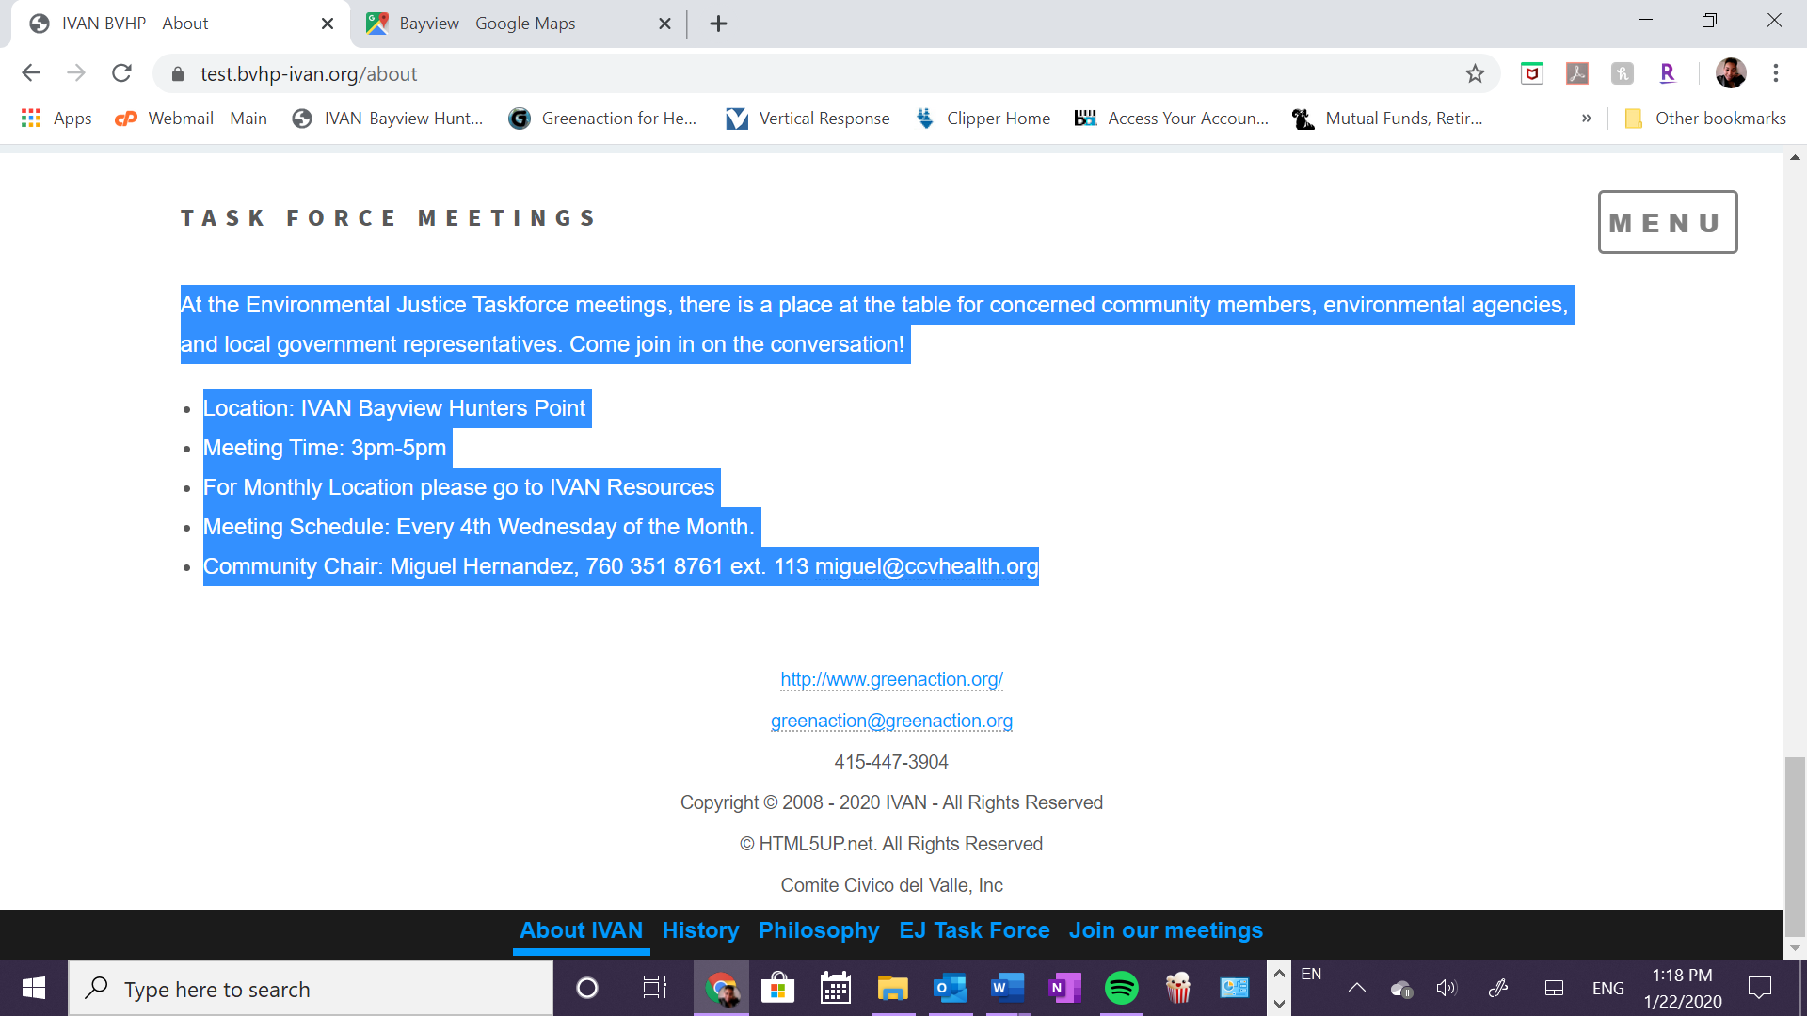
Cambiar lo siguiente:
Meeting Time: 2-4 p.m and 6-8 p.m *Time changes every other month
Meeting Schedule: Every 3rd Wednesday of the month
Community Contact: Dalila Adofo, (415) 447-3904, dalila@greenaction.org

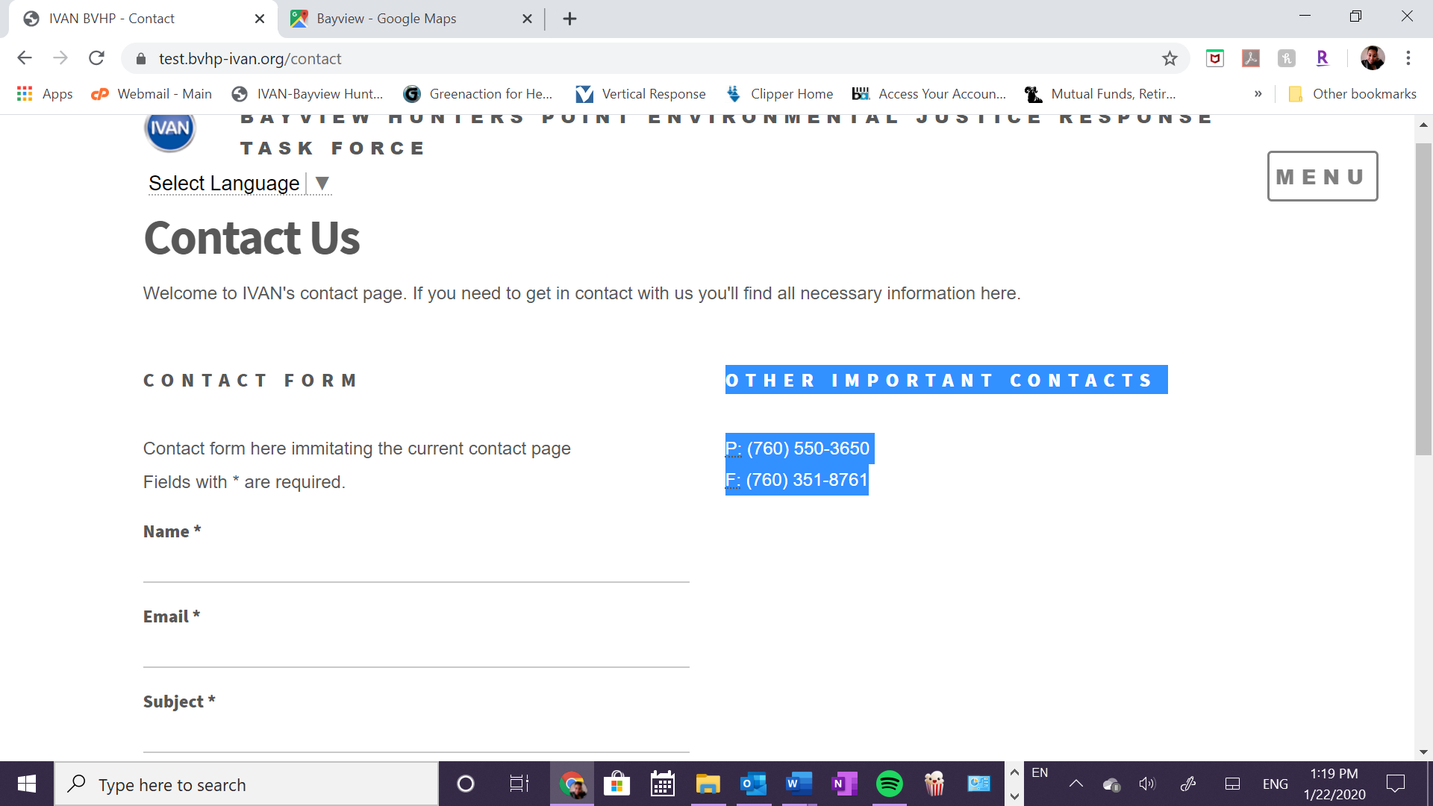
Cambiar a:
P: (415) 447-3904
E:bvhp.ivan@gmail.com

