Comments on new draft BVHP IVAN template:
Calendar and Language bar needs to on home page next to MENU:
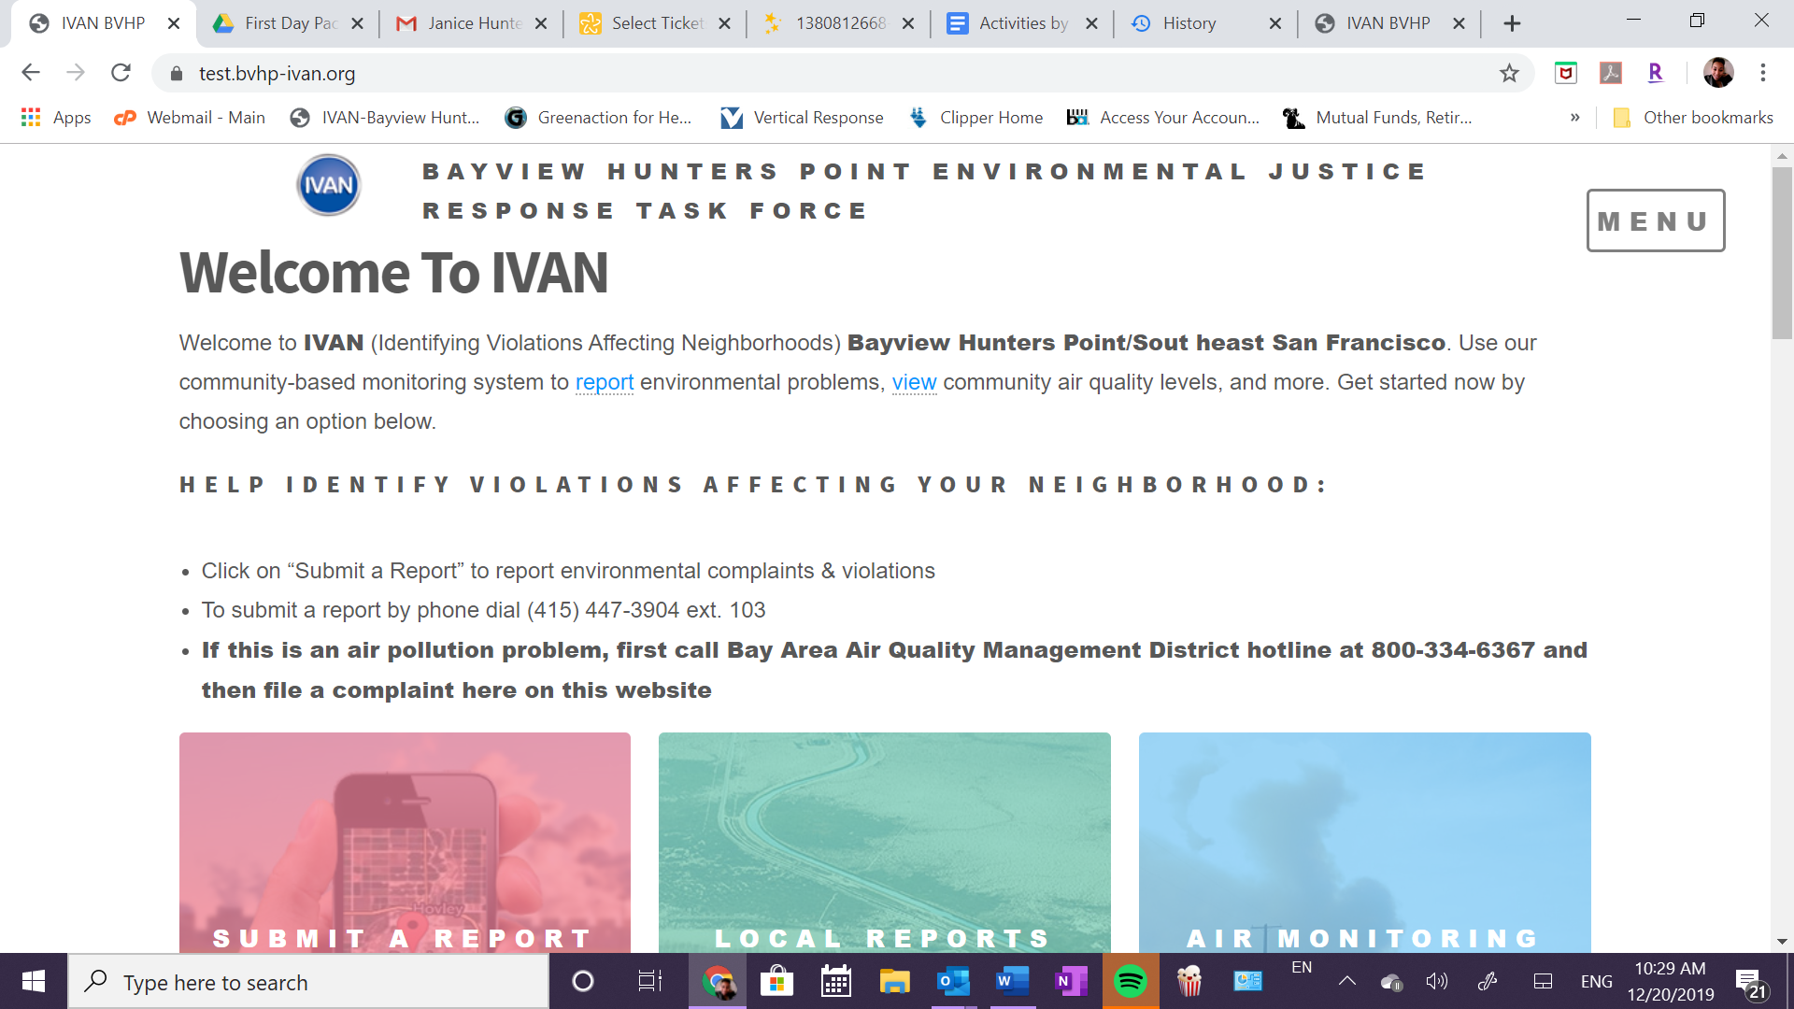
Should have Spanish, Cantonese, mandarin and tagalog options. Same as the old BVHP IVAN platform. Also, fix extra space in Southeast (circled above).
I also want to know how the administrator on the back side works for this new platform. I found that I could not upload the task force meeting calendar that showed when you clicked on the calendar next to the menu. I would like this ability moving forward.

If that’s not possible to be able to switch languages with the home page option, then should be on every page that you click on. I see it on the Submit report page but not the IVAN resources page:
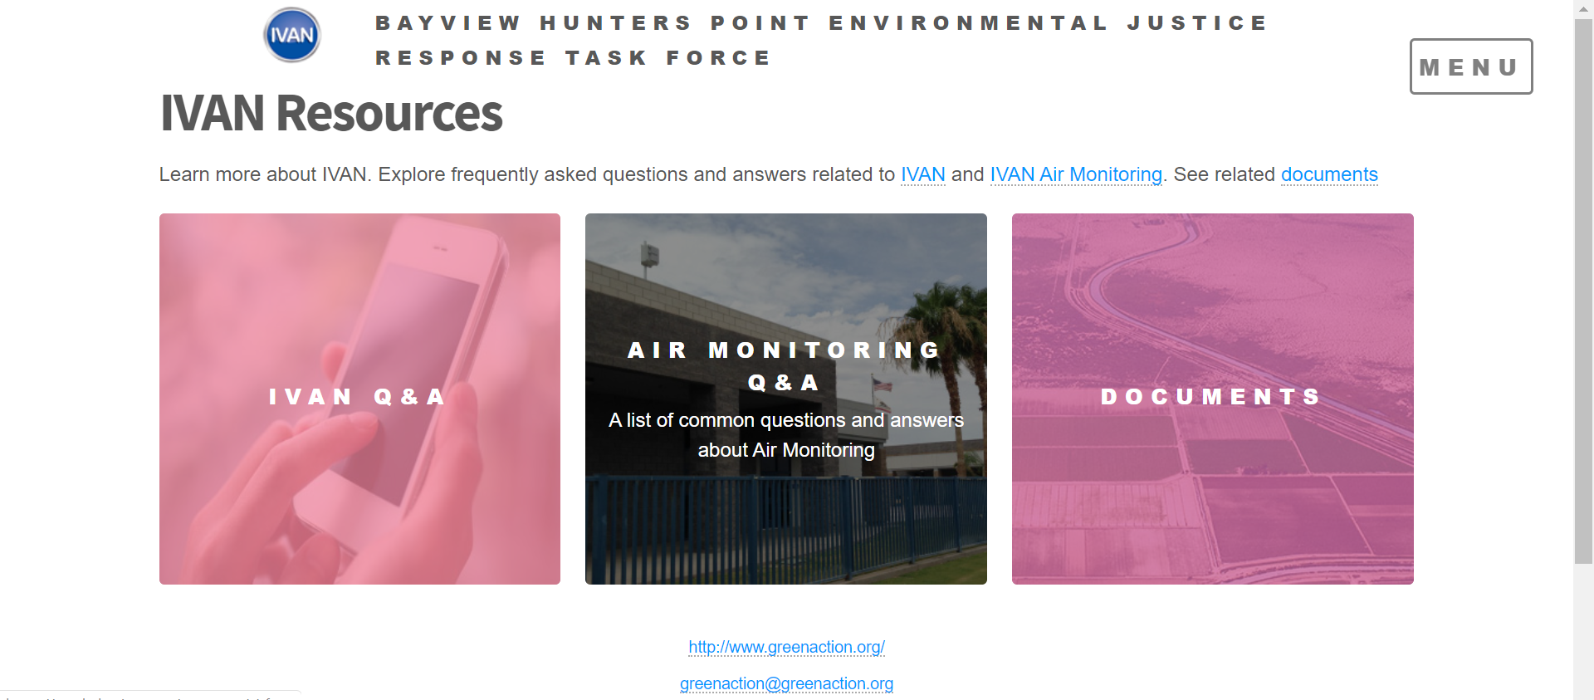
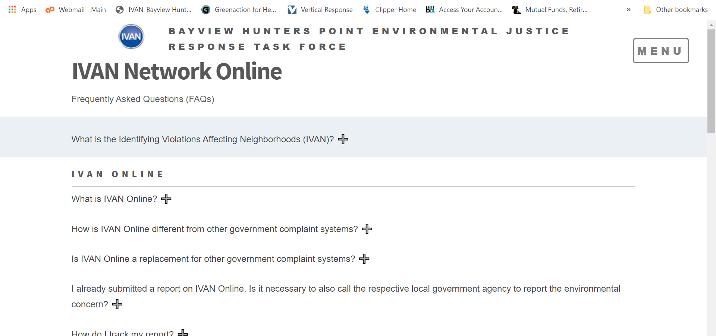
Section: How IVAN Works:
It says:
Report environmental problems in less than 5 minutes. IVAN is a community-based environmental enforcement reporting site that connects residents of the Coachella Valley with the proper agencies that can help solve local environmental problems. Whether you're at home, work, or play, IVAN is available to you and your community to report, document, and resolve environmental concerns.
Needs to be changed to:
Residents and other concerned people can report and file complaints about pollution problems in less than five minutes.
IVAN is a community-based environmental enforcement reporting site that connects residents of Bayview Hunters Point and Southeast San Francisco with the government agencies responsible for addressing and solving local environmental problems. Whether you're at home, work, school, or play, IVAN is available to you and your community to report, document, and resolve environmental concerns.

REMOVE THIS Section: How IVAN Air Monitoring works
FOR THE DISCLAIMER SECTION: BVHP IVAN is managed by Greenaction for Health and Environmental Justice and supported by Comite Civico del Valle. We are community-led environmental justice organizations working with residents to protect the health and environment of communities from pollution.

Disclaimer
IVAN Bayview Hunters Point is managed and supported by of the Comite Civico del Valle. Notes: Comite Civico del Valle is not an enforcement agency, but is an environmental conservation non-profit trying to improve the environmental regulation process in disadvantage communities.

ABOUT IVAN SECTION NEEDS MAJOR EDITING AND REWRITE:
IT SAYS:

The Environmental Justice Taskforce
The IVAN Bayview Hunters Point Environmental Justice Taskforce is a committee of dedicated people made up of residents, environmental enforcement officers, and community leaders, academia , youth , that come to together once a month to discuss reports submitted to IVAN. The IVAN Problem Solver and Government Co-Chair is a staff person at the California Regional Water Quality Control Board , and the Lead Community Co-Chair is from IVAN AiR . The Environmental Justice Taskforce meeting provides a platform for constructive dialogue between these different groups to solve environmental problems facing the local community.
Please replace above with:
The Bayview Hunters Point Environmental Justice Response Task Force is a community-led, multi-stakeholder collaborative effort and is part of the growing IVAN (Identifying Violations Affecting Neighborhoods) Network.
This project was initiated and launched in 2015 by Greenaction for Health and Environmental Justice thanks to a small grant from the California Environmental Protection Agency.
The Task Force brings together residents with community, environmental justice and health organizations, businesses and government agencies in a multi-stakeholder, problem-solving task force to remedy environmental pollution problems in the low-income community of color of Bayview Hunters Point, San Francisco.
Project goals:
- reduce pollution, protect health and promote environmental justice by improving agency and industry responses to complaints about environmental problems
- educate and empower residents to play a more active role in protecting their community, health and environment and promoting community resiliency
- improve communication and collaboration between stakeholders in order to overcome decades of lack of trust
Project components:
- multi-stakeholder community-led environmental justice task force meets monthly in Bayview Hunters Point, with meetings alternating between evening and daytime;
- Multilingual outreach to invite residents, community groups, businesses and government agencies to participate in the task force and attend meetings, and to educate people about the connection between pollution and health;
- bvhp-ivan.org website enables community members and other concerned people to file complaints and tips about pollution problems such as illegal dumping, odors and air and water pollution;
- working with the government agencies and businesses to track responses to pollution complaints;
- community leadership development and capacity building

The title needs to be our correct name: The Bayview Hunters Point Environmental Justice Response Task Force
This section should also contain a link to the agendas and minutes of the EJ Task force. After “in the low-income community of color of Bayview Hunters Point, San Francisco.” Add “View the agendas and minutes for these meetings here” Hyperlink here.
The menu also has a section on the EJ Enforcement task force, but that is not our name…this is the problem with a one sized fits all template.
The link to air monitor sections in the MENU needs to be removed, as it is not relevant to BVHP….
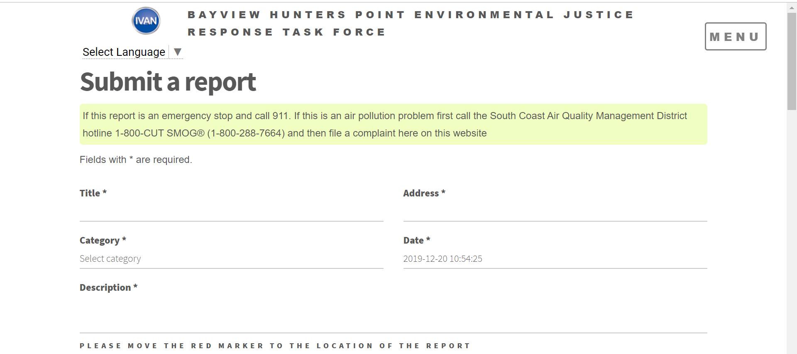
Please replace with: If this is an air pollution problem first call the Bay Area Air Management District (BAAQMD) hotline 1-800-334-ODOR (1-800-334-6367) and then file a complaint here on this website.

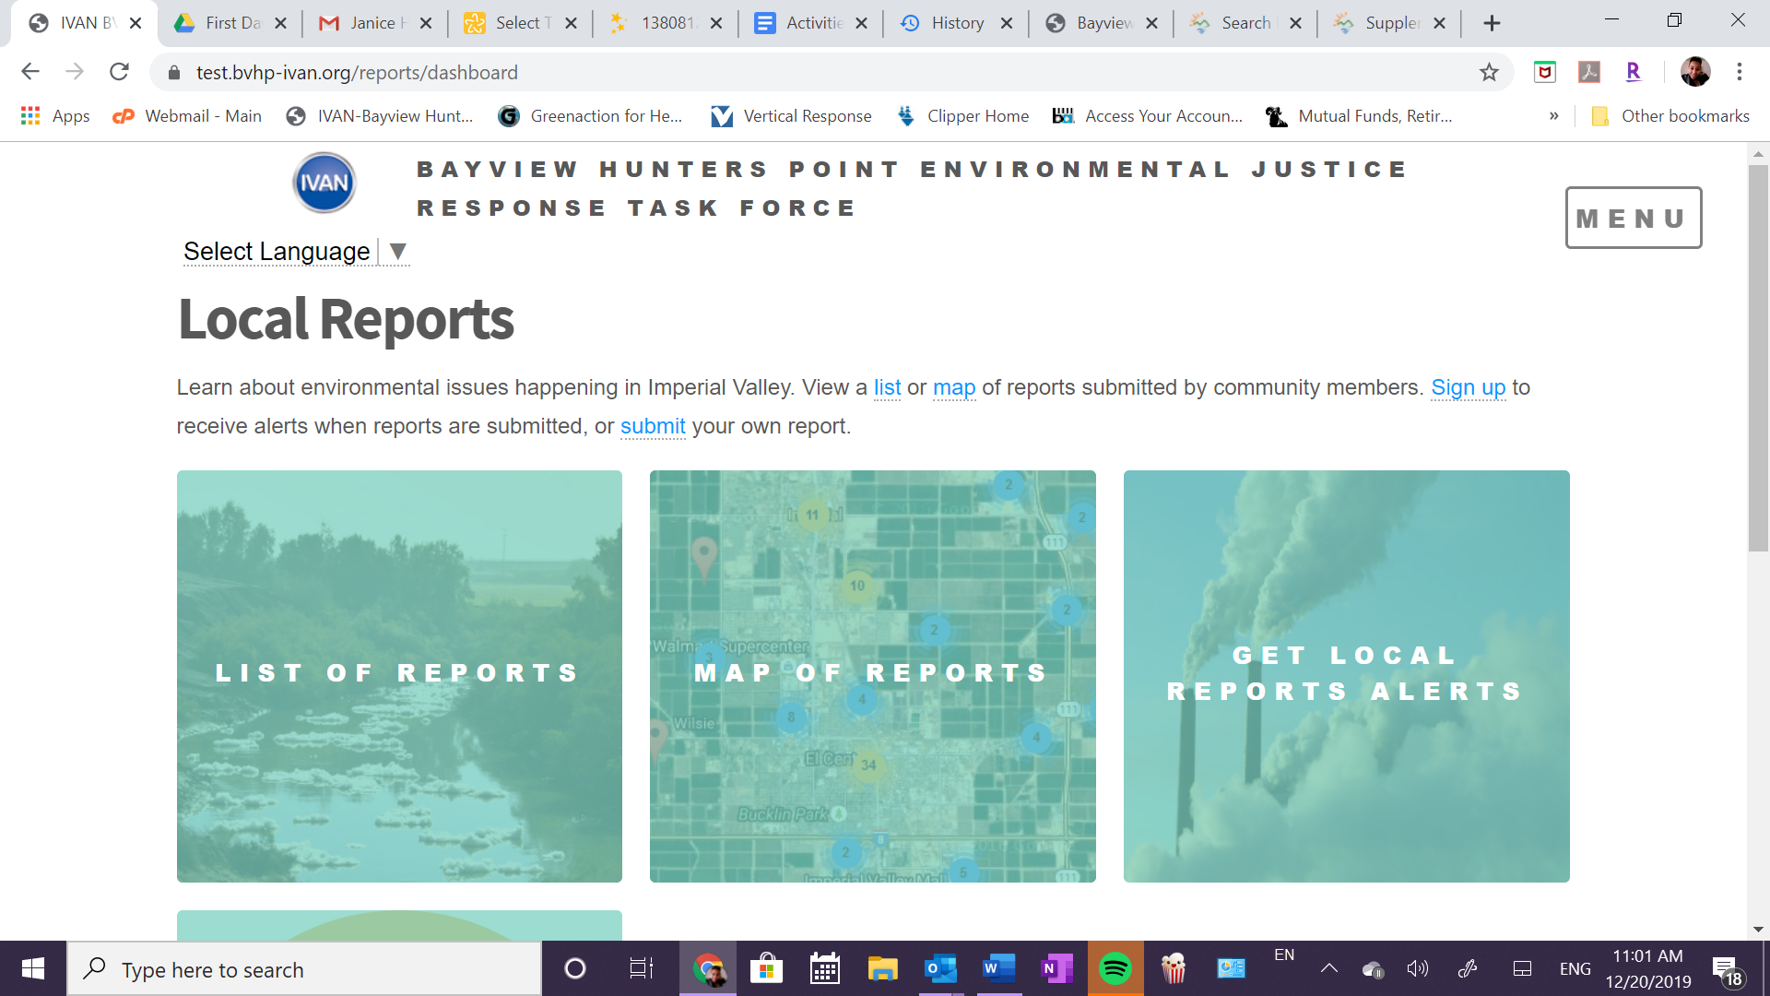
Please replace with:Bayview Hunters Point

Should remove this page or when you click on it should say “the Marie Harrison Air Monitoring Network to come at the end of 2020. Stay tuned!” 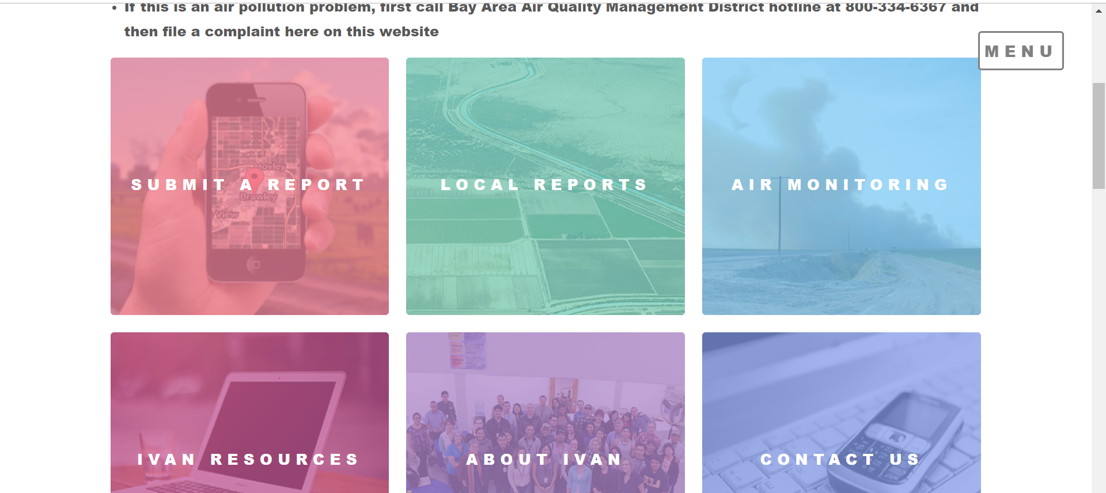

Air Monitoring Q & A should be removed or when clicked on should say “the Marie Harrison Air Monitoring Network to come at the end of 2020. Stay tuned!”.
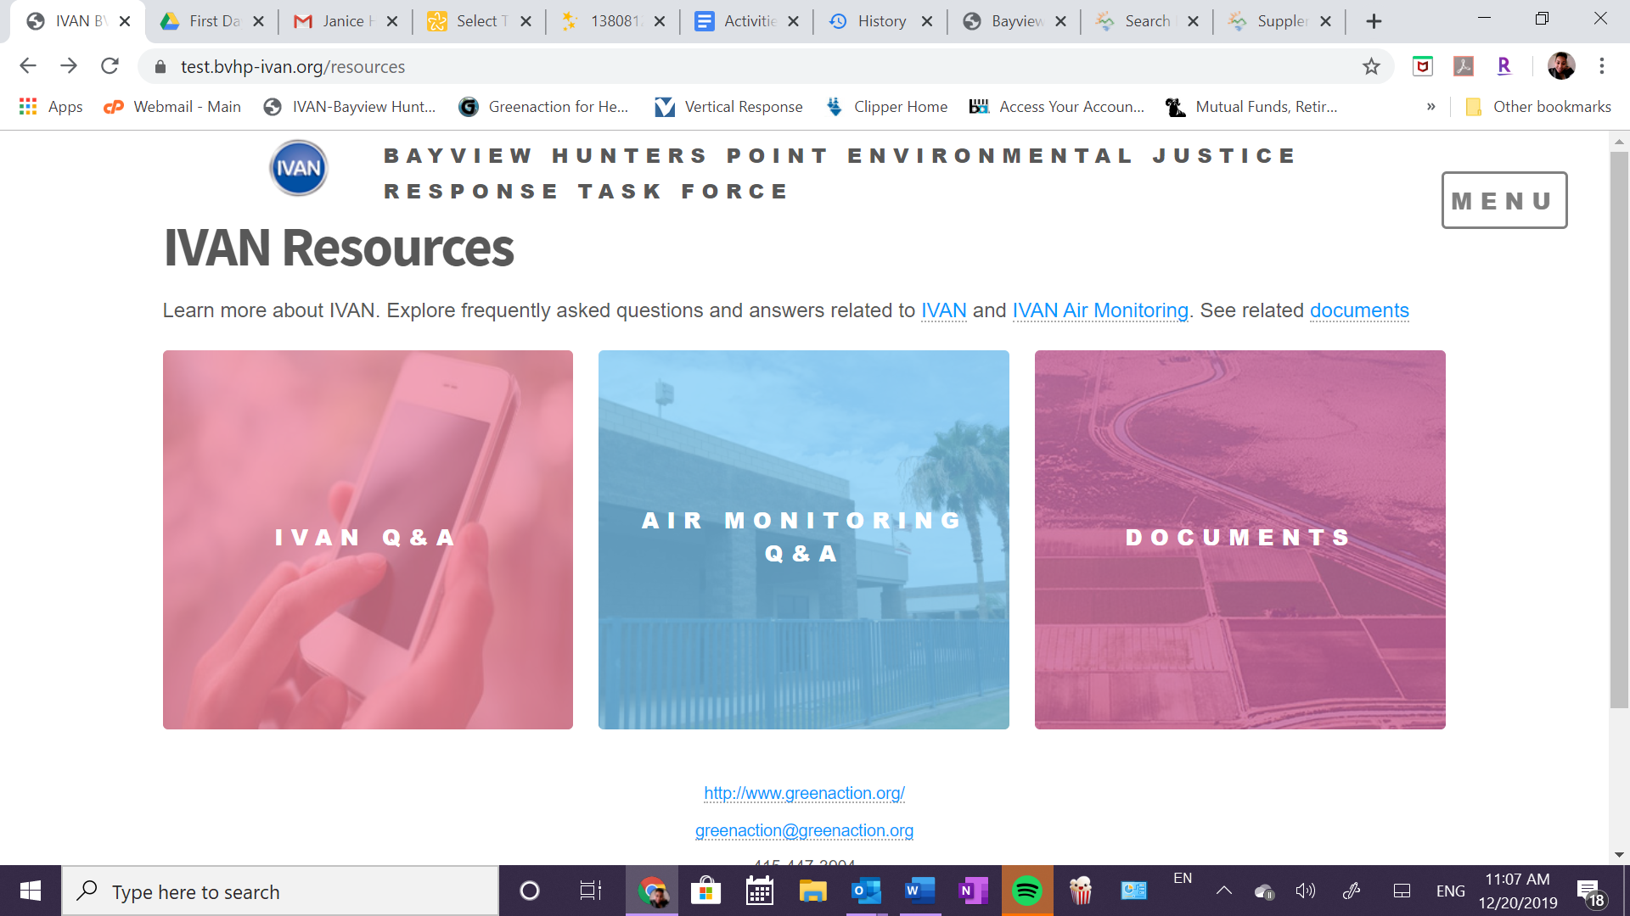

Instead of saying “see related documents” Should say “View the Bayview Hunters Point Environmental Justice Response Task Force agendas, minutes and related documents here”. Hyperlink here. Or could say “View the Bayview Hunters Point Environmental Justice Response Task Force agendas, minutes and related documents.” And hyperlink the words: agendas, minutes and documents.

Dalila- A challenge I ran into is not being able to download a specific list of reports. We show reports in the EJ task force meetings that are submitted within a month’s span (from the last meeting to current meeting) and we discuss them. It is currently hard to show these reports visually because I must click view on each one and then have each one as a separate tab. Is there another way we can visually show multiple reports easier or have it in one place? Maybe be able to download certain reports as a collective pdf? Probably something to brainstorm more but wanted to put it out there.
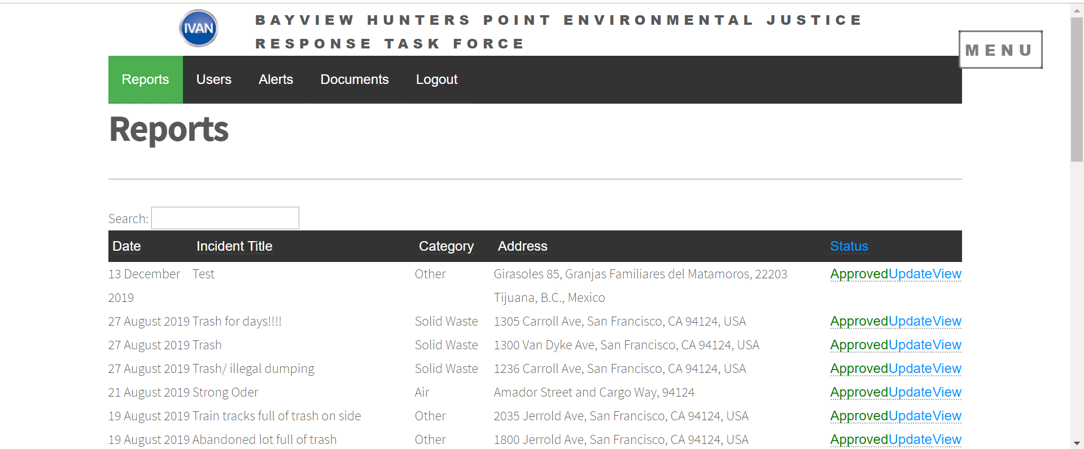
Dalila-I would also like to be able to see some more measurements but administratively. I would like to know how often a person is responding who gets an alert (would help to see if a gov agency person is not acting on alerts or maybe isn’t even seeing them). I would also like to get alerts on when a person responds to report. Sometimes I don’t realize an agency has responded until much later because I just happened to check. Would love to explore different options to improve the administrative side of things with CCV.

